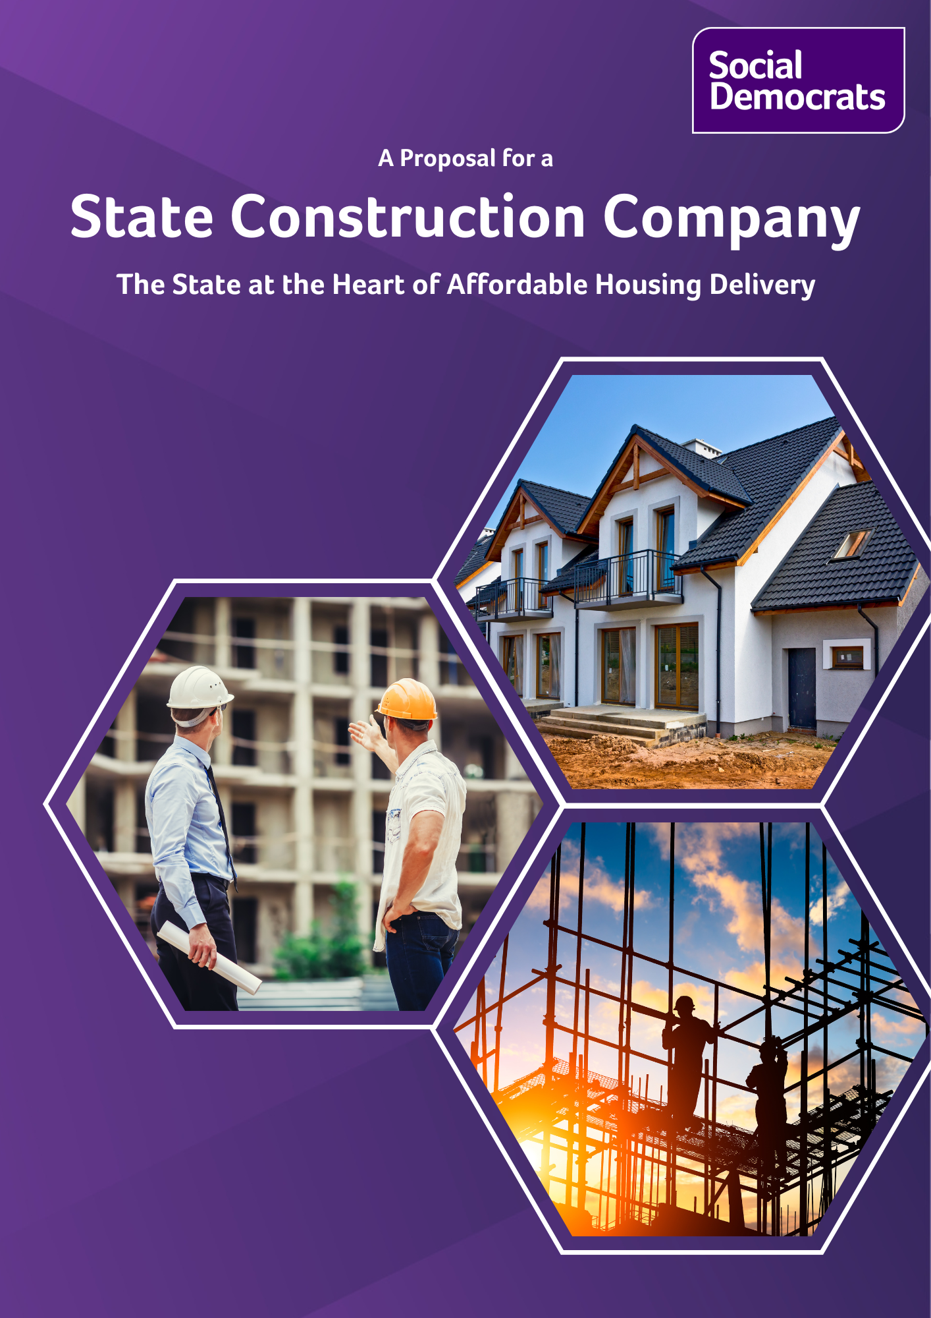
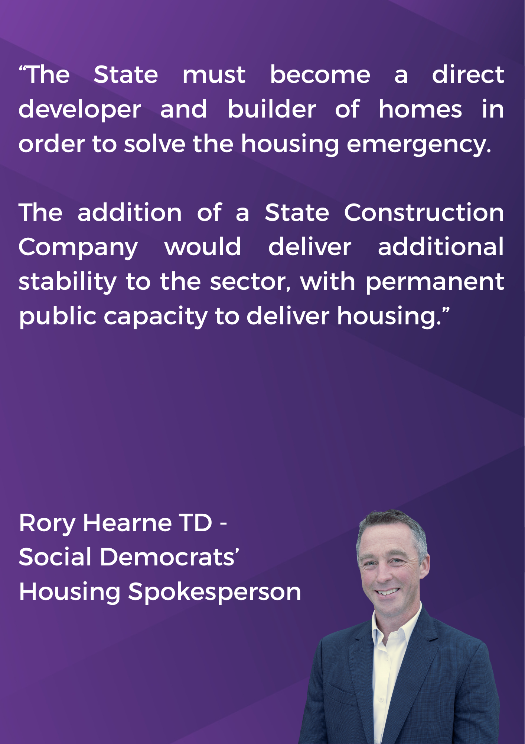

Contents

Introduction 1
Context 3
Our New Vision for Housing 5
The Ambition and Aim 6
The Steps to Get There 7
Why We Need a State Construction Company 8
Correcting Market Failure 8
A More Coordinated Approach 9
Greater Balance in the System 9
Increased Productivity, Better Value for Money 10
Better Construction Career Prospects 10
Our State Construction Company Proposal 13
Direct Employment of Building Expertise 14
Modern Methods of Construction 14
Apprenticeships 15
Creating the State Construction Company 16
What Can the State Construction Company Deliver? 17
Additional Delivery via Modern Methods of Construction 17

Introduction
Ireland’s housing emergency is worsening by the day. The Housing Commission has called for a “radical strategic reset” of housing policy, but we have seen nothing from this Government that comes close to what is necessary.
We in the Social Democrats want the State and not-for-profit housing sector to directly deliver housing on a massive scale through a historic programme of social and affordable home building. This is what the State did in Ireland in the past through local authorities and the National Building Agency. Without such direct delivery, the radical reset required to solve the housing emergency cannot be achieved.
As part of the State-led direct delivery of housing – which will involve an enhanced role for local authorities and Approved Housing Bodies – the Social Democrats, in government, will create a new State Construction Company.
This State Construction Company would mean the State itself would have construction capacity, allowing Government to move away from the current dependency on various private and market actors for the delivery of housing.
It would also give the State a means by which to directly tackle one of the biggest issues facing the construction sector; that of recruitment. For the last decade and a half, there has been a notable difficulty in attracting new workers to the construction sector at the rate required. A State Construction Company, offering decent apprenticeships with improved rates of pay, quality permanent employment, and good benefits, would play a key role in building up the skills required to tackle Ireland’s housing emergency.
The State Construction Company will also invest in Modern Methods of Construction (MMC) to ensure the State has a regular supply of modular homes. In our most recent Alternative Budget, the Social Democrats ring-fenced €120 million for investment in modular home factories to unlock the potential of this technology.
MMC is a manufacturing approach where much of the construction of buildings is transferred from building site to factory floor. MMC provide opportunity to increase productivity and efficiency in the construction sector; this in turn can accelerate the provision of housing.
The State Construction Company would set up four regional modular home factories which between them would produce up to 2,000 homes per year, mainly for local authorities.
It is important to note that private developers and private builders will still have a role in housing delivery. However, it is clear that the total reliance on private providers has failed to deliver affordable housing on the scale needed, and so a massive shift is needed. The production and output of the State Construction Company will be in addition to that from the private sector, as the Social Democrats believe that housing is a fundamental need and so – just as in other areas of fundamental importance like health and education – the State must be at the heart of delivering a basic level of provision.
Just as we do not leave it up to only the private for-profit health providers to care for our citizens, and private schools to educate them, we should not take a laissez faire approach in housing.
Under our proposal, a State Construction Company would operate alongside existing market delivery of housing, playing a significant role in the delivery of affordable and social housing.
The State Construction Company would:
- Directly employ all the necessary construction skills, including engineers, surveyors, block layers, scaffolders, carpenters, plumbers, electricians, fitters, and construction project managers.
- Provide quality permanent employment and apprenticeships, to help attract a sufficient number of workers to the sector.
- Create four regional Modular Home factories, which would between them produce up to 2,000 homes per year and allow Ireland to begin harnessing the potential efficiencies of Modern Methods of Construction.
- Work with local authorities to deliver a significant increase in the number of new homes being delivered, to meet our housing targets.

Context
As a country we have placed our economy and society in very vulnerable situation, with the supply of housing hugely dependent on prevailing market conditions, and the whims, vagaries and changing motivations of the construction industry, private finance, real estate investor funds, and for-profit developers.
Government spends a significant proportion of the housing capital budget buying housing from developers at prices dictated to them. Meanwhile a significant proportion of the current budget for housing is spent subsidising private home purchase via schemes that have been criticised by the ESRI and the Central Bank as serving mainly to keep prices artificially high, and to assist people who could already afford to buy homes to buy bigger ones.
This ‘strategy’ of throwing money at a failing market system seems primarily designed to create the impression something big is being done, but serves mainly to inflate prices in the long run and maintain the same reliance on a private delivery model that has long failed us. The boom-and-bust cycles generated by this model have left the Irish construction sector with far less capacity than is required to deliver on our housing and infrastructure needs.
- The Help to Buy Scheme will likely have cost the Exchequer around €250 million in 2025, which will bring total spend to around €1.3 billion since the scheme’s inception.
- The First Home Scheme (aka Shared Equity Scheme) is projected to cost taxpayers a total of €630 million by end of 2029.
- The Croí Cónaithe scheme, subsidising apartments, will have an estimated total cost of €450 million.
- Local Authorities are spending millions of euros on long-term leases (at market rates) of homes to provide social housing; leases that will ultimately involve paying more than the value of the house, whilst leaving the State with no asset to show for their outlay.
- Subsidies to the private rental sector (including the Housing Assistance Payment, or HAP) amounted to €700 million in 2024. If this figure persists, over €4 billion will be spent during this government’s term in office subsidising the profits of private landlords.
And as recently as three months ago, the Government cut VAT on apartments (including those already being built) with no guarantee that the reduced costs for developers (funded by taxpayers to the tune of up to nearly €400 million per year) will be passed on as savings for home buyers. The amount of waste is staggering.
While the State is not providing its own supply and has no construction capacity of its own, it is adding to the supply crisis by purchasing large amounts of social and affordable housing from the market.
The current approach to delivering affordable housing is not based on providing housing that is actually affordable, but rather on subsidising the unaffordable market price, and thereby developer profits. It is a market-driven approach to ‘affordable’ housing delivery that is not delivering houses that are actually affordable to low or middle income earners, particularly for single people.
We need a radical change in how we manage the housing system, and how we deliver affordable homes for our people.
Moves to increase the capacity of the Land Development Agency and enhance its a role as a developer of housing are welcome, if coming far too late. The State must be a direct developer and builder of homes if the housing emergency is to be solved. The addition of a State Construction Company would deliver additional stability to the sector, with permanent public capacity to directly build housing.

Our New Vision for Housing
Ahead of General Election 2024, we published our social democratic vision for the Irish housing system, including an historic State-led public affordable housing programme.
We want to transform our housing system, modelling it on the most successful aspects of the housing systems of countries like Austria, Denmark and Sweden, with housing delivery that meets housing needs. Key aspects of our vision also include:
- Significant public and ‘not for profit’ housing delivery organisations with key roles in the delivery of affordable housing, with an emphasis on enhancing the role of Approved Housing Bodies, and a getting local authorities building again.
- Greatly increased delivery of Cost Rental housing, with rents set at a level that reflect the cost of delivery and maintenance, rather than the current Government model of so-called “cost rental” where rents are linked to the market rate.
- Enhanced tenants’ rights, for those who continue to rent in the private sector.
- An approach to the development and design of neighbourhoods focused on creating sustainable communities with adequate infrastructure, transport, public services and amenities.
It is a vision that is based on the values of social democracy; a vision that understands and treats housing as its core function of being a home, not a financial asset for investors. A home is a fundamental human need, and therefore must be delivered as a public good and human right.
The countries most successful at delivering housing for their people are social democratic countries that do not leave housing to the private market alone; where the State and ‘not for profit’ sector has taken a central role in housing delivery and regulation, and considers ensuring access to decent, affordable, secure housing to be one of its core duties.
Ireland has failed in this respect because successive governments have instead taken an approach to housing that prioritises a good return on private investment and the primacy of the market; an approach where housing is treated as a commodity and financial asset rather than a home.
The result is that Ireland’s housing market has become over-financialised, run in interests of large financial institutions, investor funds, real estate investors, large developers and land and real estate speculators, rather than in the interests of ordinary people who need a home.
We need a social democratic approach that
- is culturally appropriate for Ireland,
- has strong regional and local development at its heart,
- and includes the development of large public housing and not for profit housing sectors, including cooperative housing.
Homes should be affordable, with medium density apartments and housing near the community facilities, social infrastructure and green spaces required to live a decent life from cradle to grave, including; creches, playgrounds, local sports facilities, schools, health centres, and spaces for nature.
There are examples both at home and abroad of what we aim to deliver, from Marino in Dublin to the public housing model of Vienna in Austria.
We have a vision for creating these new green affordable communities by expanding our regional cities, towns and villages. In Government, we will designate regional cities and large towns as rapid development areas that will see a focus on major housing developments, where land and infrastructure can be swiftly developed. This will include a major expansion in rail, linking cities with their suburbs and connecting them to each other. Such a move would create huge potential for housing in places like Cork, Limerick, Galway, Waterford, Athlone, Sligo, Drogheda and Dundalk.

The Ambition and Aim
- Delivering a step change in the ambition of public delivery of affordable housing.
- Increasing Ireland’s public housing stock to a minimum of 20 per cent of overall housing stock over the next two decades.
- Delivering genuinely affordable homes including affordable purchase, and cost rental housing related to income, not dictated by the market.
- Creating a supply of affordable purchase housing that would be zoned to ensure affordability in perpetuity.
- Bringing empty homes back into use by tackling vacancy and dereliction.

The Steps to Get There
- State-led aggregation and preparation of development land and infrastructure, via the Land Development Agency.
- Increased use of Compulsory Purchase Orders to acquire land for housing, and implementation of the key recommendations of the Kenny Report.
- Creation of a specific zoning for affordable housing so that only genuinely affordable homes can be built on specified areas of land, and affordability is guaranteed in perpetuity.
- Allocating additional exchequer funding to housing delivery, and creating innovative funding schemes, including our proposed Homes for Ireland Savings Scheme, to provide additional private finance for social and affordable housing.
- A delivery plan for mass refurbishment, tackling dereliction and vacancy on a coordinated and widespread scale to ensure the maximisation of existing stock, combined with a penal tax on vacancy.
- Holding a referendum to put the right to a home in the Constitution.

And important steps as part of creating this vision are:
- The creation of a State Construction Company.
- The enhancement of the capacity of the State to develop affordable and social through local authorities and ‘not for profit’ housing bodies, built by a mix of private builders and the State Construction Company.
- The development of regional modular home factories under the remit of the State Construction Company so Ireland can begin harnessing the potential efficiencies of Modern Methods of Construction.

Why We Need a State Construction Company
Reliance on private development and private building alone has left us with the current housing emergency. The State must develop public capacity to deliver social and affordable housing rapidly and on a massive scale. Current policy approaches are not delivering, and will not deliver, in a way that meets the current level of need. New approaches are needed.
While there is of course a role for the private market in meeting overall demand for housing, there is no doubt that where the market is failing to deliver enough affordable housing and enough social housing, the State must step in and take more direct measures.
It is clear that the market-led approach chosen by this Government is failing to provide sufficient development land or financing, and that there is a skills deficit relative to what is required to deliver housing on the scale needed.
In this context, a State Construction Company would be a key new dynamic that would partner with local authorities to expedite home delivery.

Correcting Market Failure
The Social Democrats believe the State must be prepared to step in to correct market failures, where the private sector is failing to deliver important social goods or meet basic needs.
Ireland has a history of successes in the area of State intervention, including through the creation of successful state and semi-state companies which have delivered important public goods and services. This includes the Electricity Supply Board (ESB), Bórd na Móna, Aer Lingus and Córas Iompair Éireann (CIE). The State Construction Company will be only the latest such intervention.
Construction, particularly home-building, is a notoriously pro-cyclical industry with too much building taking place during boom times, and far too little during recessionary periods. The State Construction Company would help to smooth the business cycle. Imagine how different Ireland’s housing situation would be if the thousands of skilled workers who emigrated or re-trained after the financial crisis were still working in construction, and available to build homes. Had the State Construction Company existed in 2009 and 2010, it could have provided the option for far more people to remain in construction-related employment, mitigating the long-term effects of economic shock.

A More Coordinated Approach
Left to its own devices, the private housing market will build in areas where it sees the greatest prospect of profit. This rarely aligns with social goals.
- Expensive build-to-rent apartments are not what people want.
- Office blocks lie empty across our cities, and yet more are being built.
- Apart-hotels and other short-stay accommodation proliferate in neighbourhoods where affordable homes are in short supply.
Greater State involvement in the construction sector will allow greater State control in delivering social goals, not just the goals of profit-seeking developers.
At a time when delivery of homes is the most pressing social concern, it is estimated that up to three quarters of construction resources (including workers) are working on projects other than new home building, including building hotels and office blocks around the country. Creating State-owned construction capacity would allow the State to have its own capacity which it could direct towards projects that are social priorities of the Government.

Greater Balance in the System
We need a functioning housing system that has a balance between market and public provision. Ireland’s dysfunctional housing market is dominated by a few very large developers and increasingly large corporate landlords holding oligopolistic control over the market, while there is very little affordable finance available for building or refurbishing homes.
There is a perception that building is not sufficiently profitable; that this constrains supply, and that if profitability improves, so too will supply. This is a very basic understanding of economics, but housing does not function like other markets. Housing markets are imperfect. Supply is often sticky. Multiple factors influence supply, from access to land and finance to planning issues and more in between.
Housing markets never work ‘perfectly’, like economic models expect, so it is up to the State to intervene where there is a failure to provide adequate affordable supply. A State Construction Company would increase the State’s capacity to intervene to achieve social goals.

Increased Productivity, Better Value for Money
The Irish construction sector has for many decades been characterised by persistently low productivity. Many builders have been slow to make use of new methods and technologies.
Higher productivity could arise from actions which lead to greater economies of scale, as the limited number of very large firms in the sector limits scope for investment in new equipment and technologies to improve productivity.
Investment in innovation drives productivity growth. The State Construction Company would be the institution through which Ireland finally begins harnessing the potential efficiencies of Modern Methods of Construction (MMC). This will include investment to build modular home factories, specialising in the delivery of 3D volumetric housing at scale. (More on Pages 14 and 17).
There is a major productivity opportunity to be reaped from shifting towards more manufacturing-based construction. MMC provide opportunity to increase productivity in the construction sector, which can in turn accelerate the delivery of housing.

Better Construction Career Prospects
For the last decade and a half, there has been a notable difficulty in attracting new workers to the construction sector at the rate required.
According to the Central Bank, total construction employment increased to 176,000 in 2024 (6.3 per cent of total employment) from its post-financial crisis trough of 85,000 in 2012 (4.5 per cent of total employment). In 2025, construction employment remained 26 per cent below its pre-financial crisis peak (237,000 in 2006, 11.1 per cent of total employment).
The Central Bank estimates that the demand for labour in the construction sector could rise to 225,000 workers in 2027, at current levels of labour productivity. This would constitute an increase of approximately 30 per cent on employment levels in 2024 and would bring actual construction employment above its pre-crisis peak.
Other estimates suggest an additional 70,000 construction workers are needed up to the end of the decade.
While increasing labour availability for the construction sector can be delivered in part through inward migration, including that facilitated by work permits for non-EU workers, there needs to be a far greater emphasis on domestic apprenticeships. However, despite a pickup in construction and engineering courses in the last number of years, apprenticeships for certain occupations such as block layers, plasterers, painters, and decorators remain low.
Construction is a notoriously precarious industry, susceptible to boom-and-bust business cycles and often characterised by subcontracting and bogus self-employment. An unwillingness to provide permanent secure employment is contributing to difficulties attracting workers to the sector. A gap has therefore emerged between what the industry is doing and the number of required apprenticeships in trades that are critical to the delivery of the housing and infrastructure which our society and economy requires. A State Construction Company, offering decent apprenticeships, quality permanent employment and good benefits, would help build up the skills required to tackle Ireland’s housing emergency.
The Industry Skills Plans UK Construction Leadership Council stated in 2022 that in order to improve apprentice numbers, and to increase skills training and diversity in the industry, it is essential to “increase the levels of direct employment, to improve the attractiveness of the sector and as a fundamental enabler of apprenticeships, career progression, upskilling, reskilling, compliance and innovation”.
Competition from a state-owned construction company – offering secure life-time pensionable careers – would also pressure the private sector to match or improve on their terms and conditions, safety standards, and benefits, or else lose the best of the workforce to the best jobs.
Employment quality matters, particularly in construction given the physical demands and the subsequent impact on health; decent conditions and benefits, including illness protection and pensions, are vital.

Another Example of a State-Owned Building Company
TRAGSA (Empresa de Transformación Agraria, SA) is a major Spanish state-owned enterprise that functions as an operational arm of the national government. The organisation plays a central role in the execution of public works, environmental protection, emergency response, and increasingly, housing construction.
Its legal status as a public corporation allows it to bypass most competitive procurement requirements, enabling governments to directly commission the company for urgent or strategic projects. This makes TRAGSA unusual compared with most European construction entities, providing the Spanish government with an agile, publicly controlled builder able to deliver works at speed and at scale.
Although historically TRAGSA’s remit was not centred on residential construction, its role in housing has grown substantially over the past decade. The organisation has constructed temporary accommodation for emergency situations, as well as permanent social housing in cooperation with regional governments. Spain’s housing affordability crisis has further elevated TRAGSA’s importance. Regional authorities have increasingly used TRAGSA for rapid delivery of publicly funded housing developments when the private market is unable or unwilling to meet demand.
The company employs thousands of staff, including engineers, architects, skilled trades, environmental technicians, and logistics personnel, creating a robust workforce capable of scaling projects quickly.
TRAGSA operates under state oversight but is self-financing through contracts awarded by public authorities. It is not a commercial competitor in open markets; instead, its clients are the Spanish state and its administrations.
Prices are regulated to reflect actual costs rather than profit maximisation. This allows TRAGSA to provide essential construction capacity in areas where private competition may be insufficient.
In housing delivery, TRAGSA’s key strengths include its speed, reliability, and ability to mobilise resources across regions. It has been used to construct modular housing units, refurbish public buildings for residential use, and develop new-build social housing.
The company also provides technical studies for urban regeneration programmes and supports local authorities in planning infrastructure needed for new residential districts. Overall, TRAGSA represents a unique public-sector tool for governments seeking to expand affordable and emergency housing capacity. Its legal and operational framework demonstrates how a state-owned construction body can operate efficiently while maintaining full public control.

Our State Construction Company Proposal
The State Construction Company would be a large publicly owned building contractor, established by legislation. It would be set up as a non-commercial semi-state for the key purpose of delivering social and affordable housing.
It would be led by a board of industry experts, with worker representation on that board, and would be accountable to the Minister for Housing.
The underpinning legislation would establish the parameters under which the Company would operate, including funding and shareholder structures, with the Minister for Housing as the sole shareholder.
Working with local authorities and under the remit of the Department of Housing, Local Government and Heritage, it would deliver a significant increase in the supply of homes, at scale and at speed, by having a singular focus to build affordable and social housing, and through the direct ownership of modular home factories.
It would not bid for contracts with commercial developers, so as to remain in line with EU rules around State Aid.
It could be contracted by local authorities to build on their behalf (including building homes in modular home factories) with local authorities acting as developer. There may be scope, eventually, to provide services too to Approved Housing Bodies and Housing Cooperatives, in line with EU State Aid and public procurement rules.
Local authorities have multiple essential functions in housing, and they should be resourced to deliver these effectively. Local authorities, however, do not have direct building capacity and housing delivery is outsourced to the private sector. The State Construction Company would be contracted to develop and build homes, with local authorities acting as developers.
In general, not-for-profit housing associations, or Approved Housing Bodies (AHBs), should also be supported to continue to expand their delivery of public housing (social and affordable). AHBs have demonstrated their ability to deliver high-quality social housing and manage estates well. Their equivalents play an important role in delivering public housing in Vienna, arguably the most successful housing model in Europe. AHBs should be supported with land and finance to expand their delivery. We envisage that the resources of the State Construction Company would eventually be available to AHBs as well, again in line with EU State Aid and public procurement rules.

Direct Employment of Building Expertise
The State Construction Company would directly employ all the necessary construction skills, including engineers, surveyors, block layers, scaffolders, carpenters, plumbers, electricians, fitters, and construction project managers.
It would have capacity to contract in additional expertise as necessary, and would be a single point of capacity and public expertise in house development and building. There would also be potential to achieve economies of scale in bulk purchasing of materials.
The State Construction Company would launch a campaign to attract back from overseas Irish construction workers who have gone abroad to ply their trade elsewhere, as well as attracting additional capacity to the sector through improved apprenticeships and more favourable working conditions in modular home factories (see next section).

Modern Methods of Construction
The Irish construction sector has for many decades been characterised by persistently low productivity when compared to other domestic sectors of the economy. The State Construction Company would be the institution through which Ireland finally begins harnessing the potential efficiencies of Modern Methods of Construction (MMC).
MMC provide opportunity to increase productivity in the construction sector, which can in turn accelerate the delivery of housing.
The State Construction Company would invest to ensure the State has a regular supply of modular homes. In our most recent Alternative Budget, the Social Democrats ring-fenced €120 million for investment in modular home factories to unlock the potential of this technology.
Based on research on similar facilities around the world in Australia, Canada and the United States, this kind of investment would create an assembly line that could produce between 1,000 and 2,000 homes per year. These home building factories would expedite the building process and give the State further additional construction capacity.
Using this €120 million funding, the State Construction Company would set up four regional factories which would produce up to 2,000 homes per year. Additional modular homes could be purchased from modular factories operating privately where necessary.
Recently we have seen modular home factories going out of the business. For this to be possible in the midst of a housing emergency is incredible and a failure of policy. For the Government to allow this to happen is downright irresponsible. The State should be playing the important role of guaranteeing demand to modular home builders, so that new technologies can be harnessed to accelerate delivery.
Local authorities should prioritise acquiring units from such factories, creating a guaranteed pipeline of demand. State ownership of modular home factories means supply lines can be vertically integrated, achieving efficiencies in the process.
Over time, MMC can lead to cost savings through economies of scale, reduced waste, and shorter construction timeframes.

Apprenticeships
As noted earlier, decent employment offers a way to attract key construction professions and trades into housing delivery. A State Construction Company, providing quality permanent employment and apprenticeships, would attract workers and provide essential capacity to deliver social and affordable homes.
Broader reform of the apprenticeship model is required outside of the State Construction Company. It is clear that low rates of pay, especially over the first two of years of construction apprenticeships, are an impediment to recruitment.
However, one innovation that the State Construction Company could bring to the table would be to increase the rates of pay to Craft Apprentices. Year 1 (€7.67 per hour) and Year 2 (€11.50 per hour) apprentices are paid below the minimum wage (€14.15 per hour, since 1 January 2026).
This gap needs to be bridged, as part of a drive to attract young men and women to the trades necessary to deliver housing on the scale needed. We cannot expect people to enter these trades if they cannot afford to support themselves.

Creating the State Construction Company
The State Construction Company would work under the remit of the Department of Housing, Local Government and Heritage. It should begin with the appointment of a Chief Operations Officer who would lead a project planning exercise to begin outlining the company structure.
As noted, the State Construction Company will directly employ all the necessary construction skills, including engineers, surveyors, block layers, scaffolders, carpenters, plumbers, electricians, and fitters. It will also employ experienced construction project managers, and have a remit to contract in additional expertise as necessary. During the initial development phases, the hiring of contractors will be an option, to give increased operation flexibility.
The Project Team will outline the necessary numbers of each craft and profession within each stage of the State Construction Company’s development, and begin a parallel scoping exercise to decide on the locations of the planned modular home factories, which would be located to serve specific regions.
This should be aligned with consultation with local authorities to agree on half a dozen designs for social homes that can be produced en mass in these factories, to ensure the size of orders that allow the factories to operate on the scale needed can be achieved.

What Can the State Construction Company Deliver?
To meet the real level of housing need, we estimate that Ireland should be delivering 40,000 social and affordable homes each year for a decade. (Add about 20,000 market-delivered homes per year on top of that for a total of 60,000 per year).
The most effective and rapid solution to deliver more social and affordable housing is through a state led delivery programme.
The State Construction Company should be delivering 5,000 social and affordable homes per year within three years.
This would include directly building 3,000 homes per year by traditional methods on building sites, and 2,000 through modular housing delivery. By the end of Year 3, we expect the State Construction to have between 4,500 and 5,000 employees (including administrative staff).
We are projecting that the start-up costs needed will be in the region of €600 million over that three-year period.
This includes €120 million to construct four regional modular home factories, to ensure the State can harness the efficiency gains for Modern Methods of Construction.
We estimate that around €480 million in additional setup costs over the first three years will be sufficient to reach this level of between 4,500 and 5,000 employees, including approximately €40 million in Year 1, €155 million in Year 2, and €285 million in Year 3.
Once the State Construction Company is fully up and running it should have no further capital injection needs, as it will be operating as a going concern, replenishing its cash holdings as it passes on the homes built.

Additional Delivery via Modern Methods of Construction
Compared to other EU jurisdictions, Ireland has been a slow adopter of Modern Methods of Construction (MMC). As noted earlier, MMC provide opportunity to increase productivity in the construction sector, which can in turn accelerate the provision of housing. This will reverse the persistently low productivity (when compared to other domestic sectors of the economy) that has characterised the construction sector for many decades.
The State Construction Company will invest to ensure the State has a regular supply of modular homes, unlocking the potential of this technology by creating an assembly line that could produce up to 2,000 homes per year. These home building factories would expedite the building process and give the State further additional construction capacity.
The State Construction Company would set up four regional factories. Additional modular homes could be purchased from modular factories operating privately. We have already seen modular home factories going out of the business because the State is not playing the important role of guaranteeing demand. This should never be the case in the midst of a housing emergency, and local authorities should prioritise acquiring units from such factories, creating a guaranteed pipeline of demand.
There is huge potential for productivity and efficiency gains using MMC. These gains cannot be fully realised when ‘orders’ for half a dozen units here and a dozen units there are the norm. It takes time for the production line for homes to be perfected, and having to set up the line completely from scratch after (for example) ten units have been produced is time-consuming and inefficient.
This ‘learning by doing’ requires a large and stable demand for homes built by MMC, and only the State is in a position to provide this guaranteed demand. The State should be creating the necessary demand that would allow modular home technology to be scaled up to level where huge gains in both cost and time and can be availed of.
By creating a set of half a dozen standardised designs that can be used across the country by all local authorities, the delivery of social and affordable homes via regional modular house factories can be ramped up significantly.
The MMC factories would specialise in 3D volumetric homes, creating full homes and large sections of homes (depending on the design type) on a production line and transporting them to site. Homes (or parts of homes in modules) would be transported to the site and lifted into place (or stacked) by cranes and connected to utilities to form the final building.
With ground preparation and development of utilities and services happening on-site as the homes are being built in the factory, overall project time can be reduced. Housing delivery would also be affected less by weather, and the fact that more work is taking place in a controlled factory environment means that levels of on-the-job safety will be higher.
Quality control of these homes will be easier, with walls, floors, ceilings, and other finishings put together on the factory floor in a production line model, allowing for a greater degree of consistency and specialisation.
MMC requires less on-site labour and can help mitigate labour constraints by relying more on off-site manufacturing processes. Over time, MMC can lead to cost savings through economies of scale, reduced waste, and shorter construction timeframes.


The Teckal principle, from EU public procurement law, allows a public body (contracting authority) to award contracts directly to a separate legal entity it controls (e.g. a State Construction Company), bypassing competitive tendering, if that entity functions like an internal department. There can be no private ownership, and at least 80 per cent of that company’s activities should be for the controlling public authority (e.g. the Department of Housing). It thereby essentially treats the contract as internal resource allocation, rather than external procurement.

